
Viewed by:
Guy SCRUIGNEC
Tel.: +33 (0)2 99 27 92 92
E-mail: guy.scruignec@iwedia.com

Written by:
Yannick PETITBOIS
Tel.: +33 (0)2 99 27 92 92
E-mail: yannick.petitbois@iwedia.com
IWEDIA

TDAL_AV Technical Specifications

V1.8

Approved by:
Thierry GARNIER
Tel.: +33 (0)2 99 27 92 92
E-mail: thierry.garnier@iwedia.com

SUMMARY
1 Reference documents 4
2 Documentation History 5
3 Introduction 7
4 Module Overview and Architecture 8
4.1 Definitions, Acronyms and Abbreviations 8
4.2 General Description 9
4.2.1 Trick modes 9
4.2.2 Interactions with TDAL_DISP module 10
4.2.3 Interactions with TDAL_DMX module 10
4.2.4 Interactions with TDAL_SPEAKERS module 10
4.2.5 Management of Dual mono audio tracks 10
4.3 Architecture 12
4.4 TDAL_AV API Description 13
4.4.1 Generic Interface 13
4.4.2 Decoding control Interface 13
4.4.3 Video decoding specific Interface 14
4.4.4 Audio decoding specific Interface 14
5 TDAL_AV API Specification 15
5.1 Type Specifications 15
5.1.1 Generic 15
5.1.2 Decoding control 15
5.1.3 Video decoding specific 15
5.1.4 Audio decoding specific 16
5.2 TDAL_AV API Usage 17
5.2.1 Start/stop one audio/video stream 17
5.2.2 Start/stop several audio/video streams 18
5.3 TDAL_AV Macro/Define/Enum/Typedef/Structure/Union Definitions 19
5.3.1 Define Definitions 19
5.3.2 Enum Definitions 19
5.3.2.1 tTDAL_AV_Error 19
5.3.2.2 tTDAL_AV_Decoder 19
5.3.2.3 tTDAL_AV_PictureType 20
5.3.2.4 tTDAL_AV_SampleType 20
5.3.2.5 tTDAL_AV_AudioType 20
5.3.2.6 tTDAL_AV_VideoType 21
5.3.2.7 tTDAL_AV_AudioStereoMode 21
5.3.2.8 tTDAL_AV_SynchroMode 22
5.3.2.9 tTDAL_AV_Event 23
5.3.2.10 tTDAL_AV_VideoAspectRatio 24
5.3.3 Typedef Definitions 24
5.3.3.1 tTDAL_AV_VideoFrameRate 24
5.3.3.2 tTDAL_AV_AudioFrequency 24
5.3.3.3 tTDAL_AV_CallbackProc_t 25
5.3.4 Structure Definitions 26
5.3.4.1 tTDAL_AV_Capability 26
5.3.4.2 tTDAL_AV_VideoCapability 27
5.3.4.3 tTDAL_AV_AudioCapability 28
5.3.4.4 tTDAL_AV_VideoResolution 29
5.3.4.5 tTDAL_AV_VideoUserData 30
5.3.5 Union Definitions 31
5.3.5.1 tTDAL_AV_StreamType 31
5.4 TDAL_AV API Functions 32
5.4.1 Generic Interface API 32
5.4.1.1 TDAL_AV_Init(-) 32
5.4.1.2 TDAL_AV_Terminate(-) 33
5.4.1.3 TDAL_AV_CapabilityGet(-) 34
5.4.1.4 TDAL_AV_APIRevisionGet(-) 35
5.4.1.5 TDAL_AV_PlatformRevisionGet(-) 36
5.4.2 Decoding control 37
5.4.2.1 TDAL_AV_EventSubscribe(-) 37
5.4.2.2 TDAL_AV_EventUnsubscribe(-) 38
5.4.2.3 TDAL_AV_Start(-) 39
5.4.2.4 TDAL_AV_Stop(-) 40
5.4.2.5 TDAL_AV_SynchroModeSet(-) 41
5.4.2.6 TDAL_AV_SpeedSet(-) 42
5.4.2.7 TDAL_AV_InputStreamSet(-) 44
5.4.3 Video decoding specific 45
5.4.3.1 TDAL_AV_VideoCapabilityGet(-) 45
5.4.3.2 TDAL_AV_VideoDestinationSet(-) 46
5.4.3.3 TDAL_AV_VideoFreeze(-) 47
5.4.3.4 TDAL_AV_VideoPictureStart(-) 48
5.4.3.5 TDAL_AV_VideoPictureStop(-) 49
5.4.3.6 TDAL_AV_VideoPictureCaptureGet(-) 50
5.4.3.7 TDAL_AV_VideoPictureCaptureRelease(-) 51
5.4.4 Audio decoding specific 52
5.4.4.1 TDAL_AV_AudioCapabilityGet(-) 52
5.4.4.2 TDAL_AV_AudioSampleStart(-) 53
5.4.4.3 TDAL_AV_AudioSampleStop(-) 54
5.4.4.4 TDAL_AV_AudioBeepPlay(-) 55
5.4.4.5 TDAL_AV_AudioStereoModeGet(-) 56
5.4.4.6 TDAL_AV_AudioStereoModeSet(-) 57
5.4.4.7 TDAL_AV_AudioDestinationSet(-) 58
5.5 TDAL_AV API Events 59
5.5.1 eTDAL_AV_EVENT_VIDEO_SEQUENCE_INFO 59
5.5.2 eTDAL_AV_EVENT_VIDEO_NEW_PICTURE_DECODED 60
5.5.3 eTDAL_AV_EVENT_VIDEO_RESOLUTION_CHANGE 61
5.5.4 eTDAL_AV_EVENT_VIDEO_ASPECT_RATIO_CHANGE 62
5.5.5 eTDAL_AV_EVENT_VIDEO_NEED_DISPLAY 63
5.5.6 eTDAL_AV_EVENT_VIDEO_USER_DATA 64
5.5.7 eTDAL_AV_EVENT_VIDEO_FRAME_RATE_CHANGE 65
5.5.8 eTDAL_AV_EVENT_AUDIO_NEW_FREQUENCY 66
5.5.9 eTDAL_AV_EVENT_AUDIO_SAMPLE_PLAYED 67
5.5.10 eTDAL_AV_EVENT_AUDIO_SAMPLE_STOPPED 68
5.5.11 eTDAL_AV_EVENT_VIDEO_PICTURE_PLAYED 69
5.5.12 eTDAL_AV_EVENT_VIDEO_PICTURE_STOPPED 70
5.5.13 eTDAL_AV_EVENT_VIDEO_TRP_SCRAMBLED_CHANGE 71

Reference documents
The following documents were used to write this specification:

Document | Version | Title
[TDAL_DISP] | V1.3 | TDAL_DISP specification
[TDAL_DMX] | V1.2 | TDAL_DMX specifications
[ETSI TR 101 154 ] | V1.7.1 | Digital Video Broadcasting (DVB);  Implementation guidelines for the use of Video and Audio Coding in Broadcasting Applications based on the MPEG-2 Transport Stream

Documentation History

History
Vers. | Date | Nature
1.0 | 04/05/2006 | YP: First version of TDAL_AV
1.1 | 19/06/2006 | GS: Review and complete documentation.  - Change a little picture play and sample play API part.  - Update/add events and add specific chapter event description.  - Change synchronisation modes.
1.2 | 21/06/2006 | GS:  - Rename TDAL_AV_SetSpeed(-) in TDAL_AV_SpeedSet(-).  - Rename TDAL_AV_SetSynchroMode(-) in TDAL_AV_SynchroModeSet(-).  - Add TDAL_AV_InputStreamSet(-) function.  - Reintroduce video sequence info event (debug need).
1.3 | 05/07/2006 | DUF :  - Add TDAL_AV_APIRevisionGet(-) and TDAL_AV_PlatformRevisionGet(-) functions.
1.4 | 19/09/2006 | GS:  - Add new video types (mpeg1, mpeg2, vc1, divx).  - Add new events (video picture played and stopped, audio sample stopped)
1.5 | 17/12/2007 | GS:  - Add new audio types (mpeg aac, he aac, e-ac3)
1.6 | 06/02/2009 | YP :  - Add eTDAL_AV_EVENT_VIDEO_TRP_SCRAMBLED_CHANGE event.
1.7 | 05/05/2009 | ARGO :  - Add note concerning management of dual mono audio tracks.
1.8 | 21/10/2009 | GS:  - Add TDAL_AV_AudioDestinationSet(-) for IDTV platform.

Introduction
The purpose of this document is to specify the interface and to describe the internal design of the Thin Driver Adaptation Layer Audio and Video Decoding [TDAL_AV]. The aim of this module is to provide a complete interface between middlewares and the audio and video decoding stage low level driver of a set-top-box.

Module Overview and Architecture

Definitions, Acronyms and Abbreviations
HDD | Hard Disk Drive
IP | Internet Protocol
AFD | Active Format Description –It is a data structure standardized in DVB that describes what portion of the picture actually contains useful information
PLL | Phase Lock Loop
AAC | Advanced Audio Coding

General Description
The main job of the TDAL_AV is to control audio/video decoding stage(s) of a set-top box.
Depending on the hardware constraints, several decoders can be controlled with two possible modes:
- External feed video/audio stream (For example, it could a stream coming from a demodulation front-end or an IP interface or a hard disk).
- Internal Memory video/audio stream.

TDAL_AV also notifies events to client when the decoding process is started.
TDAL_AV is also able to control decoder speed with different trick modes.

Trick modes
The TDAL_AV normally displays pictures and play sound at the nominal speed specified by the norm of the stream. This is the normal, automatic, non-trick-mode play. When TDAL_AV is asked to display pictures or play sound at a percentage of the nominal speed different from +100, this is what is called trick-mode play. Depending on the hardware capacities, the available trick modes can be: slow forward, fast forward, slow backward, fast backward.
Backward play may also be achieved through the display of as many pictures as possible, this is what is called ‘smooth backward’ trick modes. In some other cases, backward play may only be achieved through the display of some I pictures and display freeze in between, this is what is called ‘I only backward’ trick modes.
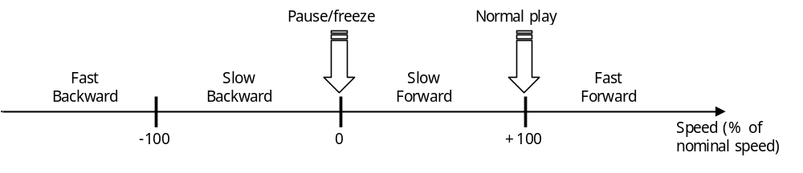

Interactions with TDAL_DISP module
TDAL_AV needs an access to the layers of TDAL_DISP to indicate in which video layers, the video decoding result must be sent.
For that purpose and to have a complete independence between the TDAL_DISP, TDAL_AV and other TDAL APIs, the notion of layer handle is used. The layer handle is an unique opaque value that is used as accessor to a specific layer. This handle is used transversely between the different TDAL modules in order to authorize a TDAL module to access the low level driver that manages the layers.
See [TDAL_DISP] for more details.

Interactions with TDAL_DMX module
TDAL_AV needs an access to the input stream of TDAL_DMX to indicate from which video or audio demultiplexer channel, the input stream is received.
For that purpose and to have a complete independence between the TDAL_DMX, TDAL_AV and other TDAL APIs, the notion of stream handle is used. The stream handle is an unique opaque value that is used as accessor to a specific video or audio stream. This handle is used transversely between the different TDAL modules in order to authorize a TDAL module to access the low level driver that manages the video or audio streams.
See [TDAL_DMX] for more details.

Interactions with TDAL_SPEAKERS module
TDAL_AV needs an access to the audio speakers post-processing of TDAL_SPEAKERS to indicate in which audio speakers, the audio decoding result must be sent.
For that purpose and to have a complete independence between the TDAL_SPEAKERS, TDAL_AV and other TDAL APIs, the notion of speaker handle is used. The speaker handle is an unique opaque value that is used as accessor to a specific speaker. This handle is used transversely between the different TDAL modules in order to authorize a TDAL module to access the low level driver that manages the speakers.
See [TDAL_SPEAKERS] for more details.

Management of Dual mono audio tracks
Usually, dual mono audio tracks are signalled in the PMT of a service by associating 2 ISO_639_language codes to one audio track. In this case, the function TDAL_AV_AudioStereoModeSet(-) is called by upper layers to select one of the 2 channels (left or right).
But some live streams do not correctly signal dual mono audio tracks : only one ISO_639_language code is defined. Therefore, it is required to force automatically "mono left" within TDAL_AV layer when a dual mono audio track is detected (using information from MPEG header).

Architecture
The figure below shows the relation between the client module and the low level drivers:
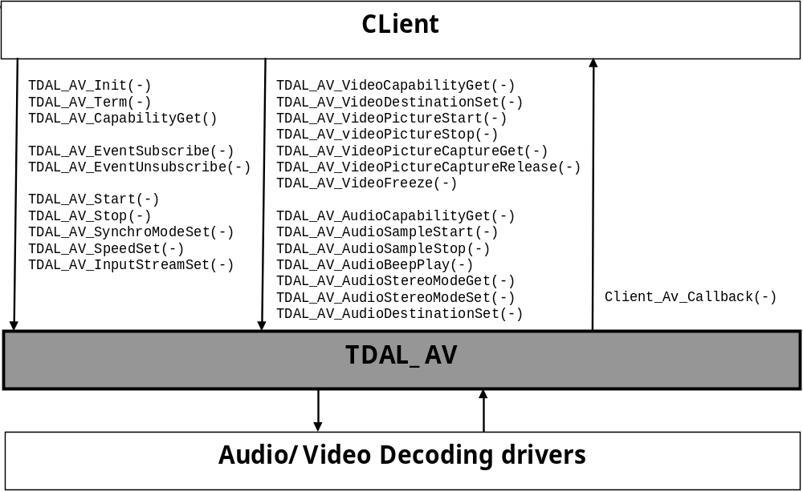

TDAL_AV API Description

Generic Interface
The generic interface allows clients to control the TDAL_AV module.
This interface is used with the following functions:
- TDAL_AV_Init(-) in order to initialize the TDAL_AV module.
- TDAL_AV_Terminate(-) in order to terminate the TDAL_AV module.
- TDAL_AV_CapabilityGet(-) in order to get the capabilities of the current implementation of TDAL_AV module.

Decoding control Interface
This interface part allows clients to control the decoding.
This interface is used with the following functions:
- TDAL_AV_EventSubscribe(-) in order to subscribe a callback for receiving a specific kind of information(event) from incoming stream
- TDAL_AV_EventUnsubscribe(-) in order to unsubscribe a subscribed callback for an event.
- TDAL_AV_Start(-) in order to start decoding a video or an audio stream.
- TDAL_AV_Stop(-) in order to stop decoding a video or an audio stream.
- TDAL_AV_SynchroModeSet(-) in order to configure the Audio and Video synchronisation mode.
- TDAL_AV_SpeedSet(-) in order to set the audio or video speed.
- TDAL_AV_InputStreamSet(-) in order to set the audio or video stream input to a specific decoder.

Video decoding specific Interface
This interface allows clients to configure the video decoding.
This interface is used with the following functions:
- TDAL_AV_VideoCapabilityGet(-) in order to get the capabilities of the current implementation of a specific video decoder in TDAL_AV module.
- TDAL_AV_VideoDestinationSet(-) in order to attach a decoder decoding result to display layer.
- TDAL_AV_VideoFreeze(-) in order to freeze the video.
- TDAL_AV_VideoPictureStart(-) in order to start playing play video from memory.
- TDAL_AV_VideoPictureStop(-) in order to stop playing play video from memory.
- TDAL_AV_VideoPictureCaptureGet(-) in order to get the currently decoded video frame.
- TDAL_AV_VideoPictureCaptureRelease(-) in order to release a previous captured video frame.

Audio decoding specific Interface
This interface allows clients to configure the audio decoding.
This interface is used with the following functions:
- TDAL_AV_AudioCapabilityGet(-) in order to get the capabilities of the current implementation of a specific audio decoder in TDAL_AV module.
- TDAL_AV_AudioSampleStart(-) in order to start playing audio from memory.
- TDAL_AV_AudioSampleStop(-) in order to stop playing audio from memory.
- TDAL_AV_AudioBeepPlay(-) in order to generates a sound.
- TDAL_AV_AudioStereoModeGet(-) in order to get the current stereo audio mode
- TDAL_AV_AudioDestinationSet(-) in order to attach a decoder to a speaker post-processor (on IDTV platform).

TDAL_AV API Specification

Type Specifications

Generic
tTDAL_AV_Capability is defined to get the capabilities of an implementation of TDAL_AV.

Decoding control
tTDAL_AV_Decoder identify a decoder instance. This instance has only a software meaning. (TDAL_AV implementation can attach an instance to one or several hardware decoders depending the kind of stream needed to be decode).
tTDAL_AV_Event is defined to list of the events a TDAL_AV client can subscribe.
tTDAL_AV_CallbackProc_t defines the prototype of the callback function called when a subscribed is notified to TDAL_AV client.
tTDAL_AV_StreamType defines the extern live audio/video stream types
tTDAL_AV_SynchroMode defines the different synchronisation modes that can be applied.

Video decoding specific
tTDAL_AV_VideoCapability is defined to get the capabilities of a video decoder implementation of TDAL_AV.
tTDAL_AV_VideoType defines the extern live video stream types
tTDAL_AV_PictureType defines the internal memory video stream types.
tTDAL_AV_VideoUserData defines the user data information found in the injected video stream.
tTDAL_AV_VideoResolution defines the resolution information found in the injected video stream.
tTDAL_AV_VideoAspectRatio defines the aspect ratio information found in the injected video stream.
tTDAL_AV_VideoFrameRate defines the frame rate information found in the injected video stream.

Audio decoding specific
tTDAL_AV_AudioCapability is defined to get the capabilities of an audio decoder implementation of TDAL_AV.
tTDAL_AV_AudioType defines the extern live audio stream types
tTDAL_AV_SampleType defines the internal memory audio stream types.
tTDAL_AV_AudioFrequency defines the frequency information found in the injected audio stream.
tTDAL_AV_AudioStereoMode defines the audio stereo mode (mono, dual right/left, stereo) to apply to the audio decoding process.

TDAL_AV API Usage

Start/stop one audio/video stream
TDAL client needs:
- To know the number of decoder instance available.
- To attach TDAL_AV decoder to a layer (see [TDAL_DISP] for more details)
- To identify the kind of Audio stream and Video stream needed to be decoded.
- To allow the access to the Audio and Video stream depending to the input device.
Then, client can ask to TDAL_AV to start/stop decoding Audio and Video.
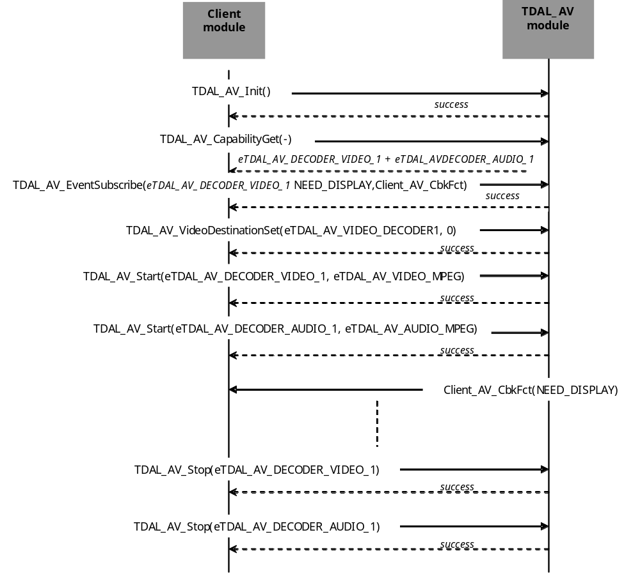

Start/stop several audio/video streams
TDAL client needs:
- To know the number of decoder instances available.
- To attach TDAL_AV decoders to a same layer in to do a PIP presentation (see [TDAL_DISP] for more details)
- To identify the kind of Audio streams and Video streams needed to be decoded.
- To allow the access to the Audio and Video streams depending to the input device.
Then, client can ask to TDAL_AV to start/stop decoding Audio and Video.
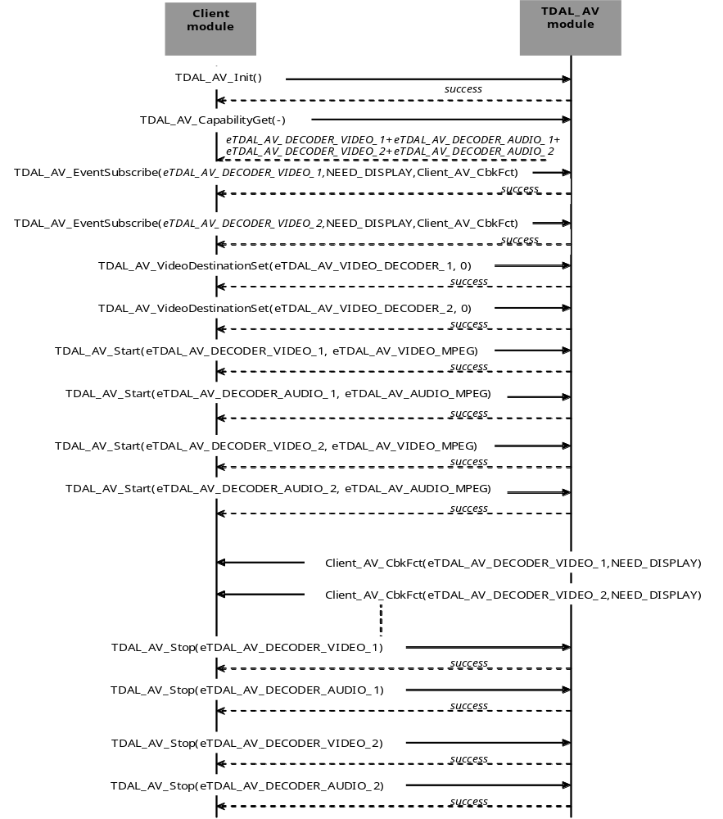

TDAL_AV Macro/Define/Enum/Typedef/Structure/Union Definitions

Define Definitions
None

Enum Definitions

tTDAL_AV_Error
An enumeration of the different error code returned by TDAL_AV.
typedef enum
{
eTDAL_AV_NO_ERROR,
eTDAL_AV_ERROR,
eTDAL_AV_BAD_PARAMETER_ERROR,
eTDAL_AV_LIMITATION_ERROR
} tTDAL_AV_Error;

tTDAL_AV_Decoder
This enumeration is firstly used to know the number of simultaneous decoders available. Then, it is used to identify one of them.
typedef enum
{
eTDAL_AV_DECODER_VIDEO_1 = 0x00000001,
eTDAL_AV_DECODER_VIDEO_2 = 0x00000002,
eTDAL_AV_DECODER_VIDEO_3 = 0x00000004,
eTDAL_AV_DECODER_VIDEO_4 = 0x00000008,
eTDAL_AV_DECODER_AUDIO_1 = 0x00000100,
eTDAL_AV_DECODER_AUDIO_2 = 0x00000200,
eTDAL_AV_DECODER_AUDIO_3 = 0x00000400,
eTDAL_AV_DECODER_AUDIO_4 = 0x00000800
} tTDAL_AV_Decoder;

tTDAL_AV_PictureType
This enumeration is firstly used to know the picture format supported and then to specify the picture format in order to display video from memory.
typedef enum
{
eTDAL_AV_PICTURE_NONE = 0x000000001,
eTDAL_AV_PICTURE_MPEG = 0x000000002,
eTDAL_AV_PICTURE_4_2_0 = 0x000000004
} tTDAL_AV_PictureType;

tTDAL_AV_SampleType
This enumeration is firstly used to know the audio format supported and then to specify the audio format in order to play audio from memory.
typedef enum
{
eTDAL_AV_SAMPLE_NONE = 0x000000001,
eTDAL_AV_SAMPLE_WAVE = 0x000000002,
eTDAL_AV_SAMPLE_MPEG1 = 0x000000004,
eTDAL_AV_SAMPLE_PCM = 0x000000008,
eTDAL_AV_SAMPLE_MPEG2 = 0x000000010,
eTDAL_AV_SAMPLE_AC3 = 0x000000020,
eTDAL_AV_SAMPLE_MP3 = 0x000000040
} tTDAL_AV_SampleType;

tTDAL_AV_AudioType
This enumeration is firstly used to know the audio format supported and then to specify the audio format in order to play audio from external source.
typedef enum
{
eTDAL_AV_AUDIO_TYPE_AC3 = 0x000000001, /* Dolby Digital (DD) */
eTDAL_AV_AUDIO_TYPE_MPEG = 0x000000002,
eTDAL_AV_AUDIO_TYPE_MPEG_AAC = 0x000000004, /* Advanced Audio Coding
ISO/IEC 13818-7 or 14496-3 */
eTDAL_AV_AUDIO_TYPE_HE_AAC = 0x000000008, /* High Eficiency AAC */
eTDAL_AV_AUDIO_TYPE_EAC3 = 0x000000010 /* Enhanced AC3 (or DD+) */
} tTDAL_AV_AudioType;

tTDAL_AV_VideoType
This enumeration is firstly used to know the video format supported and then to specify the video format in order to play video from external source.
typedef enum
{
eTDAL_AV_VIDEO_TYPE_H264 = 0x000000001, /* ISO/IEC 14496 */
eTDAL_AV_VIDEO_TYPE_MPEG2 = 0x000000002, /* ISO/IEC 13818 */
eTDAL_AV_VIDEO_TYPE_MPEG1 = 0x000000004, /* ISO/IEC 11172 */
eTDAL_AV_VIDEO_TYPE_VC1 = 0x000000008, /* SMPTE 421M */
eTDAL_AV_VIDEO_TYPE_DIVX = 0x000000010 /* ISO/IEC 14496p2=MPEG4Part2
– DivX */
} tTDAL_AV_VideoType;

tTDAL_AV_AudioStereoMode
This enumeration is used to specify the stereo audio mode when playing audio.
typedef enum
{
eTDAL_AV_AUDIO_STEREO_MODE_MONO = 0, /* Left and right input channels
are mixed and the result is
output on both front channels */
eTDAL_AV_AUDIO_STEREO_MODE_STEREO, /* Stereo output on front channels
(left and right) */
eTDAL_AV_AUDIO_STEREO_MODE_STEREO_DUAL_LEFT, /* Left channel of the
stream output both on
front channels */
eTDAL_AV_AUDIO_STEREO_MODE_STEREO_DUAL_RIGHT /* Right channel of the
stream output both on
front channels */
}tTDAL_AV_AudioStereoMode;

tTDAL_AV_SynchroMode
This enumeration is used to specify the synchronization mode when playing video and audio.
typedef enum
{
eTDAL_AV_SYNCHRO_MODE_NONE /* No synchronisation */
eTDAL_AV_SYNCHRO_MODE_LIVE_FEED, /* AV feed from live source */
eTDAL_AV_SYNCHRO_MODE_STORAGE_FEED, /* AV feed from storage source
(e.g. HDD) */
eTDAL_AV_SYNCHRO_MODE_NETWORK_FEED, /*AV feed from network source
(e.g. IP network ) */
} tTDAL_AV_SynchroMode;

tTDAL_AV_Event
This enumeration is used to register/unregister/notify an event coming from decoding process.
typedef enum
{
..eTDAL_AV_EVENT_VIDEO_SEQUENCE_INFO = 0,
eTDAL_AV_EVENT_VIDEO_NEW_PICTURE_DECODED,
eTDAL_AV_EVENT_VIDEO_RESOLUTION_CHANGE,
eTDAL_AV_EVENT_VIDEO_ASPECT_RATIO_CHANGE,
eTDAL_AV_EVENT_VIDEO_NEED_DISPLAY,
eTDAL_AV_EVENT_VIDEO_USER_DATA,
eTDAL_AV_EVENT_VIDEO_FRAME_RATE_CHANGE,
eTDAL_AV_EVENT_AUDIO_NEW_FREQUENCY,
eTDAL_AV_EVENT_AUDIO_SAMPLE_PLAYED,
eTDAL_AV_EVENT_AUDIO_SAMPLE_STOPPED,
eTDAL_AV_EVENT_VIDEO_PICTURE_PLAYED,
eTDAL_AV_EVENT_VIDEO_PICTURE_STOPPED,
eTDAL_AV_EVENT_VIDEO_TRP_SCRAMBLED_CHANGE
} tTDAL_AV_Event;
See Also:
eTDAL_AV_EVENT_VIDEO_SEQUENCE_INFO.
eTDAL_AV_EVENT_VIDEO_NEW_PICTURE_DECODED.
eTDAL_AV_EVENT_VIDEO_RESOLUTION_CHANGE
eTDAL_AV_EVENT_VIDEO_ASPECT_RATIO_CHANGE
eTDAL_AV_EVENT_VIDEO_NEED_DISPLAY
eTDAL_AV_EVENT_VIDEO_USER_DATA
eTDAL_AV_EVENT_VIDEO_FRAME_RATE_CHANGE
eTDAL_AV_EVENT_AUDIO_NEW_FREQUENCY
eTDAL_AV_EVENT_AUDIO_SAMPLE_PLAYED
eTDAL_AV_EVENT_AUDIO_SAMPLE_STOPPED
eTDAL_AV_EVENT_VIDEO_PICTURE_PLAYED
eTDAL_AV_EVENT_VIDEO_PICTURE_STOPPED
eTDAL_AV_EVENT_VIDEO_TRP_SCRAMBLED_CHANGE

tTDAL_AV_VideoAspectRatio
This enumeration is linked to eTDAL_AV_EVENT_VIDEO_ASPECT_RATIO_CHANGE event.
typedef enum
{
eTDAL_AV_ASPECT_RATIO_MPEG_4_3,
eTDAL_AV_ASPECT_RATIO_MPEG_16_9,
eTDAL_AV_ASPECT_RATIO_MPEG_1_1,
eTDAL_AV_ASPECT_RATIO_MPEG_221_1
} tTDAL_AV_VideoAspectRatio;

Typedef Definitions

tTDAL_AV_VideoFrameRate
This typedef can be used to get the frame rate from notification callback.
typedef uint32_t tTDAL_AV_VideoFrameRate

tTDAL_AV_AudioFrequency
This typedef can be used to get the audio frequency from notification callback.
typedef uint32_t tTDAL_AV_AudioFrequency

tTDAL_AV_CallbackProc_t
This typedef defines the notification callback function prototype registered to TDAL_AV :
Prototype:
typedef void (*tTDAL_AV_CallbackProc_t)
(
tTDAL_AV_Decoder decoder,
tTDAL_AV_Event event,
const void *pEventData
);
Return value:
None.
Parameters:
Parameter | Type | Dir | Description
decoder | tTDAL_AV_Decoder | In | Decoder identifier on which event occurs.
event | tTDAL_AV_Event | In | Event Constant associated with this callback invocation.
pEventData | const void * | In | Pointer to data related to the event, or a NULL pointer if there is no data.
Comments:
None.
See Also:
tTDAL_AV_Decoder.
tTDAL_AV_Event.

Structure Definitions

tTDAL_AV_Capability
Description:
This structure defines the supported features of a given implementation of TDAL_AV module.
Definition:
typedef struct
{
tTDAL_AV_Decoder decoderSupported;
} tTDAL_AV_Capability;
Elements:
Field | Type | Description
decoderSupported | tTDAL_AV_Decoder | Oring tTDAL_AV_Decoder, tells the supported decoders number and identification.
Comments:
None.
See Also:
tTDAL_AV_Decoder.
TDAL_AV_CapabilityGet(-).

tTDAL_AV_VideoCapability
Description:
This structure defines the supported features of a given decoder video implementation of TDAL_AV module.
Definition:
typedef struct
{
tTDAL_AV_PictureType pictureTypeSupported;
tTDAL_AV_VideoType videoTypeSupported;
bool isFreezeSupported;
bool isPictureCaptureSupported;
bool isSpeedSupported;
int32_t speedBackwardMax;
int32_t speedForwardMax
} tTDAL_AV_VideoCapability;
Elements:
Field | Type | Description
pictureTypeSupported | tTDAL_AV_PictureType | Oring tTDAL_AV_PictureType, tells the picture format supported. (decoding from memory)
videoTypeSupported | tTDAL_AV_VideoType | Oring tTDAL_AV_VideoType, tells the video format supported. (from external sources)
isFreezeSupported | bool | TRUE if the video decoder supports freeze of video display.
isPictureCaptureSupported | bool | TRUE if the video decoder supports video buffer capture.
isSpeedSupported | bool | TRUE if the video decoder supports speed control.
speedBackwardMax | int32_t | Backward maximum speed value in percentage of nominal speed (0 if backward not possible or a negative value).  It is only relevant if isSpeedSupported is TRUE.
speedForwardMax | int32_t | Forward maximum speed value in percentage of nominal speed (positive value).  It is only relevant if isSpeedSupported is TRUE.
Comments:
See “Trick modes” chapter for more details on speed values.
See Also:
tTDAL_AV_PictureType.
tTDAL_AV_VideoType.
TDAL_AV_VideoCapabilityGet(-).

tTDAL_AV_AudioCapability
Description:
This structure defines the supported features of a given audio decoder implementation of TDAL_AV module.
Definition:
typedef struct
{
tTDAL_AV_SampleType sampleTypeSupported;
tTDAL_AV_AudioType audioTypeSupported;
bool isBeepSupported;
bool isSpeedSupported;
int32_t speedBackwardMax;
int32_t speedForwardMax
} tTDAL_AV_AudioCapability;
Elements:
Field | Type | Description
sampleTypeSupported | tTDAL_AV_SampleType | Oring tTDAL_AV_SampleType, tells the audio format supported (decoding from memory)
audioTypeSupported | tTDAL_AV_AudioType | Oring tTDAL_AV_AudioType, tells the audio format supported (from external sources)
isBeepSupported | bool | TRUE if beep tone feature is supported.
isSpeedSupported | bool | TRUE if the audio decoder supports speed control.
speedBackwardMax | int32_t | Backward maximum speed value in percentage of nominal speed (0 if backward not possible or a negative value).  It is only relevant if isSpeedSupported is TRUE.
speedForwardMax | int32_t | Forward maximum speed value in percentage of nominal speed (positive value).  It is only relevant if isSpeedSupported is TRUE.
Comments:
See “Trick modes” chapter for more details on speed values.
See Also:
tTDAL_AV_SampleType.
tTDAL_AV_AudioType.
TDAL_AV_AudioCapabilityGet(-).

tTDAL_AV_VideoResolution
Description:
This structure defines the video resolution.
Definition:
typedef struct
{
uint16_t width;
uint16_t height;
} tTDAL_AV_VideoResolution;
Elements:
Field | Type | Description
width | uint16_t | Video width in pixel
height | uint16_t | Video height in pixel
Comments:
This structure is used as data associated with eTDAL_AV_EVENT_VIDEO_RESOLUTION_CHANGE.
See Also:
tTDAL_AV_CallbackProc_t.
eTDAL_AV_EVENT_VIDEO_RESOLUTION_CHANGE.

tTDAL_AV_VideoUserData
Description:
This structure defines parameters allowing to retrieve user data extracted from the injected video stream.
Definition:
typedef struct
{
uint8_t AFD;
} tTDAL_AV_VideoUserData;
Elements:
Field | Type | Description
AFD | uint8_t | AFD code (See [ETSI TR 101 154 ])
Comments:
This structure is used as data associated with eTDAL_AV_EVENT_VIDEO_USER_DATA.
See Also:
tTDAL_AV_CallbackProc_t.
eTDAL_AV_EVENT_VIDEO_USER_DATA.

Union Definitions

tTDAL_AV_StreamType
Description:
This union defines the audio or video type.
Definition:
typedef union
{
tTDAL_AV_VideoType videoType;
tTDAL_AV_AudioType audioType;
} tTDAL_AV_StreamType;
Elements:
Field | Type | Description
videoType | tTDAL_AV_VideoType | Video stream type.
audioType | tTDAL_AV_AudioType | Audio stream type.
Comments:
This union is usually used in conjunction with a specific audio or video decoder.
See Also:
tTDAL_AV_Decoder.
tTDAL_AV_AudioType.
tTDAL_AV_VideoType.
TDAL_AV_Start(-).

TDAL_AV API Functions

Generic Interface API

TDAL_AV_Init(-)
Prototype:
tTDAL_AV_Error TDAL_AV_Init (void);
Description:
This function initialises the TDAL_AV module.
Return value:
It returns eTDAL_AV_NO_ERROR if initialization succeed.
Parameters:
None.
Comments:
This function must be called before any other functions of the TDAL_AV API.
See Also:
TDAL_AV_Terminate(-).

TDAL_AV_Terminate(-)
Prototype:
tTDAL_AV_Error TDAL_AV_Terminate (void);
Description:
This function terminates the TDAL_AV module.
Return value:
It returns eTDAL_AV_NO_ERROR if succeed.
Parameters:
Comments:
This function frees resources and terminates TDAL_AV module.
Any function of TDAL_DISP API should not be called after TDAL_AV_Terminate(-) call.
See Also:
TDAL_AV_Init(-).

TDAL_AV_CapabilityGet(-)
Prototype:
tTDAL_AV_Error TDAL_AV_CapabilityGet
(
tTDAL_AV_Capability *pstCapability
);
Description:
This function retrieves the capabilities of the TDAL_AV current implementation.
Return value:
It returns eTDAL_AV_NO_ERROR if succeed.
Parameters:
Parameter | Type | Dir | Description
pstCapability | tTDAL_AV_Capability * | In/Out | In: Allocated capability structure pointer.  Out: Structure filled with capabilities of the implementation of the TDAL_AV module.
Comments:
This function can be called at any time the TDAL_AV has been initialised with TDAL_AV_Init(-) but not after the termination with TDAL_AV_Terminate(-).
See Also:
tTDAL_AV_Capability.

TDAL_AV_APIRevisionGet(-)
Prototype:
Cont char *TDAL_AV_APIRevisionGet(void);
Description:
This function retrieves the API revision.
Return value:
A string containing the revision of the TDAL_AV API.
Parameters:
None.
Comments:
This function can be called at any time.
See Also:

TDAL_AV_PlatformRevisionGet(-)
Prototype:
Const char *TDAL_AV_PlatformRevisionGet(void);
Description:
This function retrieves the platform implementation revision.
Return value:
A string containing the revision of the TDAL_AV implementation on a platform.
Parameters:
None.
Comments:
This function can be called at any time.
See Also:

Decoding control

TDAL_AV_EventSubscribe(-)
Prototype:
tTDAL_AV_Error TDAL_AV_EventSubscribe
(
tTDAL_AV_Decoder decoder,
tTDAL_AV_Event event,
tTDAL_AV_CallbackProc_t notifyFunction
);
Description:
This function subscribes a callback functions for a specific event.
Return value:
It returns eTDAL_AV_NO_ERROR if event subscription succeed.
If event is not supported by the specified decoder, eTDAL_AV_BAD_PARAMETER_ERROR is returned.
If decoder identifier is not supported, eTDAL_AV_LIMITATION_ERROR is returned.
Parameters:
Parameter | Type | Dir | Description
decoder | tTDAL_AV_Decoder | In | Decoder identifier
event | tTDAL_AV_Event | In | Event identifier
notifyFunction | tTDAL_AV_CallbackProc_t | In | Pointer on a callback function
Comments:
When event occurred for the specified decoder the callback is called.
See Also:
tTDAL_AV_Decoder.
tTDAL_AV_Event.
tTDAL_AV_CallbackProc_t.

TDAL_AV_EventUnsubscribe(-)
Prototype:
tTDAL_AV_Error TDAL_AV_EventUnsubscribe
(
tTDAL_AV_Decoder decoder,
tTDAL_AV_Event event
);
Description:
This function unsubscribes a callback function for a previous subscribed event.
Return value:
It returns eTDAL_AV_NO_ERROR if succeed.
If event is not supported or not subscribed by the specified decoder, eTDAL_AV_BAD_PARAMETER_ERROR is returned.
If decoder identifier is not supported, eTDAL_AV_LIMITATION_ERROR is returned.
Parameters:
Parameter | Type | Dir | Description
decoder | tTDAL_AV_Decoder | In | Decoder identifier
event | tTDAL_AV_Event | In | Event identifier
Comments:
None.
See Also:
tTDAL_AV_Decoder.
tTDAL_AV_Event.

TDAL_AV_Start(-)
Prototype:
tTDAL_AV_Error TDAL_AV_Start
(
tTDAL_AV_Decoder decoder,
tTDAL_AV_StreamType streamType
);
Description:
This function starts a decoding process from external sources (Audio or Video).
Return value:
It returns eTDAL_AV_NO_ERROR if succeed.
If stream type is not supported by the specified decoder, eTDAL_AV_BAD_PARAMETER_ERROR is returned.
If decoder identifier is not supported, eTDAL_AV_LIMITATION_ERROR is returned.
Parameters:
Parameter | Type | Dir | Description
decoder | tTDAL_AV_Decoder | In | Decoder identifier
streamType | tTDAL_AV_StreamType | In | Stream type depending on decoder (Audio or Video)
Comments:
After the start is effective, subscribed events can be notified.
See Also:
tTDAL_AV_Decoder.
tTDAL_AV_StreamType.
TDAL_AV_Stop(-).

TDAL_AV_Stop(-)
Prototype:
tTDAL_AV_Error TDAL_AV_Stop
(
tTDAL_AV_Decoder decoder
);
Description:
This function stop a decoding process from external sources (Audio or Video).
Return value:
It returns eTDAL_AV_NO_ERROR if succeed.
If decoder identifier is not supported, eTDAL_AV_LIMITATION_ERROR is returned.
Parameters:
Parameter | Type | Dir | Description
decoder | tTDAL_AV_Decoder | In | Decoder identifier
Comments:
After the stop is effective, subscribed events are not anymore notified.
See Also:
tTDAL_AV_Decoder.
TDAL_AV_Start(-).

TDAL_AV_SynchroModeSet(-)
Prototype:
tTDAL_AV_Error TDAL_AV_SynchroModeSet
(
tTDAL_AV_Decoder videoDecoder,
tTDAL_AV_Decoder audioDecoder,
tTDAL_AV_SynchroMode mode
);
Description:
This function sets the synchronisation mode of the specified audio/video decoders.
Return value:
It returns eTDAL_AV_NO_ERROR if succeed.
If synchronisation mode is not supported by the specified decoders, eTDAL_AV_BAD_PARAMETER_ERROR is returned.
If decoder identifier is not supported, eTDAL_AV_LIMITATION_ERROR is returned.
Parameters:
Parameter | Type | Dir | Description
videoDecoder | tTDAL_AV_Decoder | In | Video decoder identifier
audioDecoder | tTDAL_AV_Decoder | In | Audio decoder identifier
mode | tTDAL_AV_SynchroMode | In | Synchronisation mode to be set.
Comments:
None.
See Also:
tTDAL_AV_Decoder.
tTDAL_AV_SynchroMode.

TDAL_AV_SpeedSet(-)
Prototype:
tTDAL_AV_Error TDAL_AV_SpeedSet
(
tTDAL_AV_Decoder decoder,
int32_t speed
);
Description:
This function sets the speed of the specified decoder.
Return value:
It returns eTDAL_AV_NO_ERROR if succeed.
If speed is not supported by the specified decoder, eTDAL_AV_BAD_PARAMETER_ERROR is returned.
If decoder identifier is not supported, eTDAL_AV_LIMITATION_ERROR is returned.
Parameters:
Parameter | Type | Dir | Description
decoder | tTDAL_AV_Decoder | In | Decoder identifier
speed | int32_t | In | Speed in percentage factor of the nominal speed.
Comments:
This function is used to enter the trick mode, where a stream can be displayed/listened at a speed different from the nominal speed specified by the norm of the stream. This can be used to play the stream in slow forward, fast forward, slow backward, and fast backward. Trick modes are generally to be used only in a non ‘on air’ environment (e.g. playing back from hard disk or DVD...). Note that a perfect backward display quality (called ‘smooth backward’) is only reachable on some decoder device but not all.
The required speed is expressed as a percentage factor of the nominal speed where value of 100 corresponds to the ‘normal’ speed: positive values less than 100 are used for forward slow motion.
Values greater than 100 are used for fast forward. Negatives values are used for reverse slow motion or fast rewind. The value 0 will freeze (pause) the decoding process.
Setting the speed to a value different from +100 prevents the synchronization from being performed. Setting the speed back to +100 allows the synchronization to be performed again.
See “Trick modes” chapter for more details on speed values.
See Also:
tTDAL_AV_Decoder.

TDAL_AV_InputStreamSet(-)
Prototype:
tTDAL_AV_Error TDAL_AV_InputStreamSet
(
tTDAL_AV_Decoder decoder,
uint32_t streamHandle
);
Description:
This function attaches a stream input to a video or an audio decoder.
Return value:
It returns eTDAL_AV_NO_ERROR if succeed.
If the stream can not be set as input of the decoder, eTDAL_AV_BAD_PARAMETER_ERROR is returned.
If decoder identifier is not supported, eTDAL_AV_LIMITATION_ERROR is returned.
Parameters:
Parameter | Type | Dir | Description
decoder | tTDAL_AV_Decoder | In | Decoder identifier
streamHandle | uint32_t | In | Stream identifier (see [TDAL_DMX] for more details on how to retrieve the stream identifier value)
Comments:
See. “Interactions with TDAL_DMX module” chapter for more details.
This function must be called when the decoder is stopped and not playing video picture or audio sample.
See Also:
tTDAL_AV_Decoder.

Video decoding specific

TDAL_AV_VideoCapabilityGet(-)
Prototype:
tTDAL_AV_Error TDAL_AV_VideoCapabilityGet
(
tTDAL_AV_Decoder decoder,
tTDAL_AV_VideoCapability *pstCapability
);
Description:
This function retrieves the capabilities of the defined TDAL_AV video decoder.
Return value:
It returns eTDAL_AV_NO_ERROR if retrieve of capabilities succeed. It could be eTDAL_AV_ERROR otherwise.
If video decoder identifier is not supported, eTDAL_AV_LIMITATION_ERROR is returned.
Parameters:
Parameter | Type | Dir | Description
decoder | tTDAL_AV_Decoder | In | Video decoder identifier.
pstCapability | tTDAL_AV_VideoCapability * | In/Out | In: Allocated capability structure pointer.  Out: Structure filled with video decoder capabilities of the implementation of the TDAL_AV module.
Comments:
To know the number of available decoder(s), TDAL_AV_CapabilityGet(-) must be called first.
This function can be called at any time the TDAL_AV has been initialised with TDAL_AV_Init(-) but not after the termination with TDAL_AV_Terminate(-).
See Also:
tTDAL_AV_Decoder.
tTDAL_AV_VideoCapability.

TDAL_AV_VideoDestinationSet(-)
Prototype:
tTDAL_AV_Error TDAL_AV_VideoDestinationSet
(
tTDAL_AV_Decoder decoder,
uint32_t layerHandle
);
Description:
This function attaches a decoder to a video display layer.
Return value:
It returns eTDAL_AV_NO_ERROR if succeed.
If the layer can not be set as destination of the decoder, eTDAL_AV_BAD_PARAMETER_ERROR is returned.
If video decoder identifier is not supported, eTDAL_AV_LIMITATION_ERROR is returned.
Parameters:
Parameter | Type | Dir | Description
decoder | tTDAL_AV_Decoder | In | Decoder identifier
layerHandle | uint32_t | In | Layer identifier (see [TDAL_DISP] for more details on how to retrieve the layer identifier value)
Comments:
See. “Interactions with TDAL_DISP module” chapter for more details.
See Also:
tTDAL_AV_Decoder.

TDAL_AV_VideoFreeze(-)
Prototype:
tTDAL_AV_Error TDAL_AV_VideoFreeze
(
tTDAL_AV_Decoder decoder
);
Description:
This function freezes the video display. The video decode goes on.
Return value:
It returns eTDAL_AV_NO_ERROR if succeed.
If video decoder identifier or freeze control is not supported, eTDAL_AV_LIMITATION_ERROR is returned.
Parameters:
Parameter | Type | Dir | Description
decoder | tTDAL_AV_Decoder | In | Decoder identifier
Comments:
None.
See Also:
tTDAL_AV_Decoder.

TDAL_AV_VideoPictureStart(-)
Prototype:
tTDAL_AV_Error TDAL_AV_VideoPictureStart
(
tTDAL_AV_Decoder decoder,
tTDAL_AV_PictureType pictureType,
uint8_t* pData,
uint32_t size
);
Description:
This function starts a video decoding from memory and display it.
Return value:
It returns eTDAL_AV_NO_ERROR if video picture play succeed.
If picture type is not supported by the specified decoder, eTDAL_AV_BAD_PARAMETER_ERROR is returned.
If pData is NULL and/or size is 0, eTDAL_AV_BAD_PARAMETER_ERROR is returned.
If video decoder identifier or picture play control is not supported, eTDAL_AV_LIMITATION_ERROR is returned.
Parameters:
Parameter | Type | Dir | Description
decoder | tTDAL_AV_Decoder | In | Decoder identifier
pictureType | tTDAL_AV_PictureType | In | Picture Buffer format
pData | uint8_t* | In | Data buffer containing a picture corresponding to the picture type
size | uint32_t | In | Data buffer Size
Comments:
After the start is effective, subscribed events can be notified.
See Also:
tTDAL_AV_Decoder.
tTDAL_AV_PictureType.
TDAL_AV_VideoPictureStop(-).

TDAL_AV_VideoPictureStop(-)
Prototype:
tTDAL_AV_Error TDAL_AV_VideoPictureStop
(
tTDAL_AV_Decoder decoder
);
Description:
This function stops a decoding process from memory.
Return value:
It returns eTDAL_AV_NO_ERROR if succeed.
It return a eTDAL_AV_ERROR if a previous starts has not been made.
If decoder identifier is not supported, eTDAL_AV_LIMITATION_ERROR is returned.
Parameters:
Parameter | Type | Dir | Description
decoder | tTDAL_AV_Decoder | In | Decoder identifier
Comments:
The stops cleans TDAL_AV or low level internal memory buffer and removes the picture from the display.
After the stop is effective, subscribed events are not anymore notified.
See Also:
tTDAL_AV_Decoder.
TDAL_AV_VideoPictureStart(-).

TDAL_AV_VideoPictureCaptureGet(-)
Prototype:
tTDAL_AV_Error TDAL_AV_VideoPictureCaptureGet
(
tTDAL_AV_Decoder decoder,
tTDAL_AV_PictureType pictureType,
uint8_t** ppData,
uint32_t *pSize
);
Description:
This function gets the current decoded picture by the specified decoder and convert it into the specified picture type and store it in ppData.
Return value:
It returns eTDAL_AV_NO_ERROR if succeed.
If picture type is not supported by the specified decoder, eTDAL_AV_BAD_PARAMETER_ERROR is returned.
If ppData is NULL and/or pSize is NULL, eTDAL_AV_BAD_PARAMETER_ERROR is returned.
If video decoder identifier or picture capture control is not supported, eTDAL_AV_LIMITATION_ERROR is returned.
Parameters:
Parameter | Type | Dir | Description
decoder | tTDAL_AV_Decoder | In | Decoder identifier
pictureType | tTDAL_AV_PictureType | In | Requested picture type
ppData | uint8_t** | In/Out | In: Allocated pointer to a data buffer pointer.  Out: Pointer to the captured data buffer.
pSize | uint32_t* | In/Out | In: allocated size pointer.  Out: Size of captured buffer.
Comments:
None.
See Also:
tTDAL_AV_Decoder.
tTDAL_AV_PictureType.

TDAL_AV_VideoPictureCaptureRelease(-)
Prototype:
tTDAL_AV_Error TDAL_AV_VideoPictureCaptureRelease
(
tTDAL_AV_Decoder decoder,
tTDAL_AV_PictureType pictureType,
uint8_t* pData,
uint32_t size
);
Description:
This function releases a previous captured decoded picture done by the specified decoder
Return value:
It returns eTDAL_AV_NO_ERROR if succeed.
If picture type is not supported by the specified decoder, eTDAL_AV_BAD_PARAMETER_ERROR is returned.
If pData is NULL and/or size is 0, eTDAL_AV_BAD_PARAMETER_ERROR is returned.
If video decoder identifier or picture capture control is not supported, eTDAL_AV_LIMITATION_ERROR is returned.
If any previous captured pictures corresponds to the input parameters, eTDAL_AV_ERROR is returned.
Parameters:
Parameter | Type | Dir | Description
decoder | tTDAL_AV_Decoder | In | Decoder identifier
pictureType | tTDAL_AV_PictureType | In | Captured picture type
pData | uint8_t* | In | Out: Pointer to the previous captured data buffer.
size | uint32_t | In | Size of captured buffer.
Comments:
After this call, the use of pData pointer is not allowed by TDAL_AV client.
See Also:
tTDAL_AV_Decoder.
tTDAL_AV_PictureType.

Audio decoding specific

TDAL_AV_AudioCapabilityGet(-)
Prototype:
tTDAL_AV_Error TDAL_AV_AudioCapabilityGet
(
tTDAL_AV_Decoder decoder,
tTDAL_AV_AudioCapability *pstCapability
);
Description:
This function retrieves the capabilities of the defined TDAL_AV audio decoder.
Return value:
It returns eTDAL_AV_NO_ERROR if retrieve of capabilities succeed. It could be eTDAL_AV_ERROR otherwise.
If audio decoder identifier is not supported, eTDAL_AV_LIMITATION_ERROR is returned.
Parameters:
Parameter | Type | Dir | Description
decoder | tTDAL_AV_Decoder | In | Audio decoder identifier.
pstCapability | tTDAL_AV_AudioCapability * | In/Out | In: Allocated capability structure pointer.  Out: Structure filled with audio decoder capabilities of the implementation of the TDAL_AV module.
Comments:
To know the number of available decoder(s), TDAL_AV_CapabilityGet(-) must be called first.
This function can be called at any time the TDAL_AV has been initialised with TDAL_AV_Init(-) but not after the termination with TDAL_AV_Terminate(-).
See Also:
tTDAL_AV_Decoder.
tTDAL_AV_AudioCapability.

TDAL_AV_AudioSampleStart(-)
Prototype:
tTDAL_AV_Error TDAL_AV_AudioSampleStart
(
tTDAL_AV_Decoder decoder,
tTDAL_AV_SampleType sampleType,
uint8_t* pData,
uint32_t size,
uint16_t nbTimes
);
Description:
This function starts a audio decoding from memory.
Return value:
It returns eTDAL_AV_NO_ERROR if succeed.
If sample type is not supported by the specified decoder, eTDAL_AV_BAD_PARAMETER_ERROR is returned.
If pData is NULL and/or size is 0, eTDAL_AV_BAD_PARAMETER_ERROR is returned.
If audio decoder identifier or sample play control is not supported, eTDAL_AV_LIMITATION_ERROR is returned.
Parameters:
Parameter | Type | Dir | Description
Decoder | tTDAL_AV_Decoder | In | Decoder identifier
sampleType | tTDAL_AV_SampleType | In | Audio Sample Buffer format
pData | uint8_t* | In | Pointer to data buffer containing an audio sample corresponding to the sample type
size | uint32_t | In | Data buffer size
nbTimes | uint16_t | In | Specify how many times the sample should be played
Comments:
This function is asynchronous and after the start is effective, subscribed events eTDAL_AV_EVENT_AUDIO_NEW_FREQUENCY and eTDAL_AV_EVENT_AUDIO_SAMPLE_PLAYED can be notified.
See Also:
tTDAL_AV_Decoder.
tTDAL_AV_SampleType.
TDAL_AV_AudioSampleStop(-).

TDAL_AV_AudioSampleStop(-)
Prototype:
tTDAL_AV_Error TDAL_AV_AudioSampleStop
(
tTDAL_AV_Decoder decoder
);
Description:
This function stops a decoding process from memory.
Return value:
It returns eTDAL_AV_NO_ERROR if succeed.
It return a eTDAL_AV_ERROR if a previous starts has not been made.
If decoder identifier is not supported, eTDAL_AV_LIMITATION_ERROR is returned.
Parameters:
Parameter | Type | Dir | Description
decoder | tTDAL_AV_Decoder | In | Decoder identifier
Comments:
The stop command cleans TDAL_AV or low level internal memory buffer and disable the sound.
After the stop is effective, subscribed events are not anymore notified.
See Also:
tTDAL_AV_Decoder.
TDAL_AV_AudioSampleStart(-).

TDAL_AV_AudioBeepPlay(-)
Prototype:
tTDAL_AV_Error TDAL_AV_AudioBeepPlay
(
tTDAL_AV_Decoder decoder
uint16_t frequency,
uint16_t duration
);
Description:
This function plays a beep sound.
Return value:
It returns eTDAL_AV_NO_ERROR if succeed.
If frequency is not supported, eTDAL_AV_BAD_PARAMETER_ERROR is returned.
If audio decoder identifier or beep play control is not supported, eTDAL_AV_LIMITATION_ERROR is returned.
Parameters:
Parameter | Type | Dir | Description
decoder | tTDAL_AV_Decoder | In | Decoder identifier
frequency | uint16_t | In | Beep frequency in Hz.
duration | uint16_t | In | Beep duration in ms.
Comments:
This function is synchronous and returns until the beep duration has been reached.
See Also:
None.

TDAL_AV_AudioStereoModeGet(-)
Prototype:
tTDAL_AV_Error TDAL_AV_AudioStereoModeGet
(
tTDAL_AV_Decoder decoder,
tTDAL_AV_AudioStereoMode *pstMode
);
Description:
This functions gets the current stereo mode.
Return value:
It returns eTDAL_AV_NO_ERROR if succeed.
Parameters:
Parameter | Type | Dir | Description
decoder | tTDAL_AV_Decoder | In | Decoder identifier.
pstMode | tTDAL_AV_AudioStereoMode* | In/Out | In: allocated pointer to audio stereo mode.  Out: pointer filled with current audio stereo mode
Comments:
None.
See Also:
tTDAL_AV_Decoder.
tTDAL_AV_AudioStereoMode.
TDAL_AV_AudioStereoModeSet(-).

TDAL_AV_AudioStereoModeSet(-)
Prototype:
tTDAL_AV_Error TDAL_AV_AudioStereoModeSet
(
tTDAL_AV_Decoder decoder,
tTDAL_AV_AudioStereoMode mode
);
Description:
The function sets the specified stereo mode.
Return value:
It returns eTDAL_AV_NO_ERROR if succeed.
Parameters:
Parameter | Type | Dir | Description
decoder | tTDAL_AV_Decoder | In | Decoder identifier
mode | tTDAL_AV_AudioStereoMode | In | Audio stereo mode to be set.
Comments:
None.
See Also:
tTDAL_AV_Decoder.
tTDAL_AV_AudioStereoMode.

TDAL_AV_AudioDestinationSet(-)
Prototype:
tTDAL_AV_Error TDAL_AV_AudioDestinationSet
(
tTDAL_AV_Decoder decoder,
uint32_t speakerHandle
);
Description:
This function attaches a decoder to a speaker post-processor
Return value:
It returns eTDAL_AV_NO_ERROR if operation succeed.
Parameters:
Parameter | Type | Dir | Description
decoder | tTDAL_AV_Decoder | In | Decoder identifier
SpeakerHandle | uint32_t | In | Speaker handle
Comments:
This function is dedicated to IDTV platform and is irrelevant for STB platform.
This function must be called to indicate where the audio decoding result must be sent. It allows in managing the video flow connection between an analog audio decoder and a speaker post-processor output. The layer handler is given by TDAL_SPEAKER module.
See “Interactions with TDAL_SPEAKERS module” chapter for more details.
This function can be can called several times with different speaker handles.
So, this function has to remove the current speaker handle from other available implemented decoders if needed.
Only the same unique speaker destination from one decoder is possible. And it is possible to have several different speaker destinations to one decoder.
For example, headphone speakers could play the same or a different audio stream than the main speakers.
See Also:
tTDAL_AV_Decoder.

TDAL_AV API Events

eTDAL_AV_EVENT_VIDEO_SEQUENCE_INFO
Description:
This event is notified when next sequence found in video decoder input buffer has new information.
Data:
None.
Comments:
This event is always notified once after the first sequence after a TDAL_AV_Start(), as TDAL_AV considers that there was no sequence before. Then, it is notified only when one of the following information is changing in the new coming sequence: height, width, aspect ratio, scan type, frame rate, MPEG standard.
This event can be notified when the video decoder is running, and also when the display is freezed (decode is going-on), but not when the driver is stopped.
This event could be used as debug purpose to check that good data are send to the video decoder.
See Also:
tTDAL_AV_Event.
tTDAL_AV_CallbackProc_t.

eTDAL_AV_EVENT_VIDEO_NEW_PICTURE_DECODED
Description:
This event is notified when a new picture has just been decoded.
Data:
None.
Comments:
This event is notified when the decoding of a new picture has been done. So it is notified when a video decoder is started, and also when the display is freezed (decode is going-on), but not when the decoder is stopped.
See Also:
tTDAL_AV_Event.
tTDAL_AV_CallbackProc_t.

eTDAL_AV_EVENT_VIDEO_RESOLUTION_CHANGE
Description:
This event is notified when next picture to be displayed has a new resolution compared to the previous displayed picture.
Data:
tTDAL_AV_VideoResolution | Parameters of the current video resolution.
Comments:
This event reflects changes in the resolution of the pictures as defined in the stream according to the norm, independently of the scan type of the video output stage.
This event is notified only when a video decoder is started. It is not notified when it is stopped or freezed.
This event is notified once when the first picture is displayed after a TDAL_AV_Start(-) call, as the TDAL_AV module considers that there was no picture displayed before.
See Also:
tTDAL_AV_Event.
tTDAL_AV_CallbackProc_t.
tTDAL_AV_VideoResolution.

eTDAL_AV_EVENT_VIDEO_ASPECT_RATIO_CHANGE
Description:
This event is notified when next picture to be displayed has a new resolution compared to the previous displayed picture.
Data:
tTDAL_AV_VideoAspectRatio | Parameters of the current video aspect ratio.
Comments:
This event reflects changes in the aspect ratio of the pictures as defined in the stream according to the norm, independently of the scan type of the video output stage.
This event is notified only when a video decoder is started. It is not notified when it is stopped or freezed.
This event is notified once when the first picture is displayed after a TDAL_AV_Start(-) call, as the TDAL_AV module considers that there was no picture displayed before.
See Also:
tTDAL_AV_Event.
tTDAL_AV_CallbackProc_t.
tTDAL_AV_VideoAspectRatio.

eTDAL_AV_EVENT_VIDEO_NEED_DISPLAY
Description:
This event is notified when a new picture will be presented on display on the next vertical synchronisation signal.
Data:
None.
Comments:
This event is notified for the display of each new picture. So it is notified only when the video part of TDAL_AV is running. It is not notified when the video is stopped or freezed.
See Also:
tTDAL_AV_Event.
tTDAL_AV_CallbackProc_t.

eTDAL_AV_EVENT_VIDEO_USER_DATA
Description:
This event is notified when user data information are found in the video injected stream.
Data:
tTDAL_AV_VideoUserData | Parameters of the received video user data.
Comments:
This event is notified as soon as user data is found in the injected video stream. So user data are notified in the same order as they are stored in the stream, and with no time constraints in regards to the decoding or display process of TDAL_AV.
This event can be notified when the video part of TDAL_AV is running, and also when the display is freezed (decode is going-on), but not when the video is stopped.
See Also:
tTDAL_AV_Event.
tTDAL_AV_CallbackProc_t.
tTDAL_AV_VideoUserData.

eTDAL_AV_EVENT_VIDEO_FRAME_RATE_CHANGE
Description:
This event is notified when next picture to be displayed has a new frame rate compared to the previous displayed picture.
Data:
tTDAL_AV_VideoFrameRate | Parameters of the current video frame rate.
Comments:
This event reflects changes in the frame rate of the pictures as defined in the stream according to the norm, independently of the scan type of the video output stage.
This event is notified only when a video decoder is started. It is not notified when it is stopped or freezed.
This event is notified once when the first picture is displayed after a TDAL_AV_Start(-) call, as the TDAL_AV module considers that there was no picture displayed before.
See Also:
tTDAL_AV_Event.
tTDAL_AV_CallbackProc_t.
tTDAL_AV_VideoFrameRate.

eTDAL_AV_EVENT_AUDIO_NEW_FREQUENCY
Description:
This event is notified when a sampling frequency change has been detected by the audio decoder.
Data:
tTDAL_AV_AudioFrequency | Parameters of the current audio frequency.
Comments:
Where the audio output are configured to use an internal PLL the new sampling rate is automatically applied, allowing seamless configuration of the audio output stage.
Otherwise the user should subscribe to this event and reprogram the external PLL in accordance with the new sampling frequency detected on the input stream.
See Also:
tTDAL_AV_Event.
tTDAL_AV_CallbackProc_t.
tTDAL_AV_AudioFrequency.

eTDAL_AV_EVENT_AUDIO_SAMPLE_PLAYED
Description:
This event is notified when a audio sample play command has finished.
Data:
None.
Comments:
This event is notified after TDAL_AV_AudioSampleStart(-) has been called and the audio sample play command has reached the end.
If a call to TDAL_AV_AudioSampleStop(-) has been made before the end of the audio sample command, this event is not notified.
See Also:
tTDAL_AV_Event.
tTDAL_AV_CallbackProc_t.

eTDAL_AV_EVENT_AUDIO_SAMPLE_STOPPED
Description:
This event is notified when a audio sample stop command has finished.
Data:
None.
Comments:
This event is notified after TDAL_AV_AudioSampleStop(-) has been called after the audio sample play command has reached the end
If a call to TDAL_AV_AudioSampleStop(-) has been made before the end of the audio sample command, this event is also notified.
See Also:
tTDAL_AV_Event.
tTDAL_AV_CallbackProc_t.

eTDAL_AV_EVENT_VIDEO_PICTURE_PLAYED
Description:
This event is notified when a video picture play command has finished.
Data:
None.
Comments:
This event is notified after TDAL_AV_VideoPictureStart(-) has been called and the video picture play command has reached the end.
If a call to TDAL_AV_VideoPictureStop(-) has been made before the end of the video picture command, this event is not notified.
See Also:
tTDAL_AV_Event.
tTDAL_AV_CallbackProc_t.

eTDAL_AV_EVENT_VIDEO_PICTURE_STOPPED
Description:
This event is notified when a video picture stop command has finished.
Data:
None.
Comments:
This event is notified after TDAL_AV_VideoPictureStop(-) has been called after the video picture play command has reached the end
If a call to TDAL_AV_VideoPictureStop(-) has been made before the end of the video picture command, this event is also notified.
See Also:
tTDAL_AV_Event.
tTDAL_AV_CallbackProc_t.

eTDAL_AV_EVENT_VIDEO_TRP_SCRAMBLED_CHANGE
Description:
This event is notified when a video PES scrambled bit changed.
Data:
uint32_t | 0 or 1
Comments:
This event is notified each time scrambled bit change, or the first time the video started
Parameter must be filled with 0 -> Clear or 1 -> Scrambled.
See Also:
tTDAL_AV_Event.
tTDAL_AV_CallbackProc_t.

